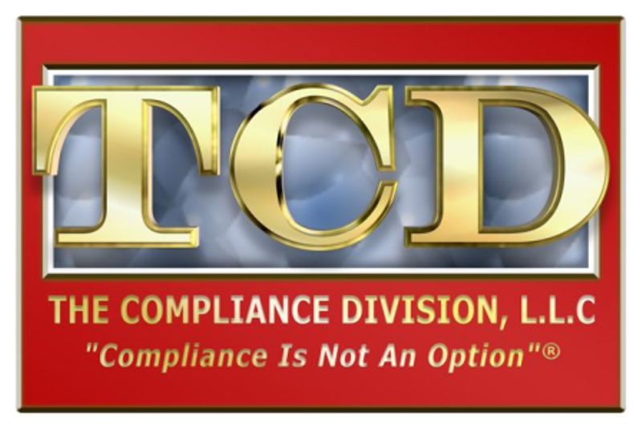
P.O. Box 780034
San Antonio, TX 78278-0034
210-493-2999
210-493-3002 Fax
www.thecompliancedivision.com

MANUAL ORDER FORM
THE COMPLIANCE DIVISION, L.L.C.
(2024)

Publications available for order through TCD are listed below for your convenience. The manuals provided by TCD are intended to assist the employer in achieving compliance with federal and state regulations and are not intended as legal or accounting advice. Purchase of the manuals and updates are not a guarantee of compliance. Fax the completed form to TCD at 210-493-3002.

Date: _______________________ Specialty:
Employer or Practice Name:
Address:
City: State: ZIP:
Telephone: Fax:
Employer Representative:

Please send me the manual(s) marked below:
I understand I will be billed the full amount of the manual plus appropriate sales tax, shipping and handling and agree to pay the invoice in full upon receipt.
I wish to pay by credit card. (Please call us at 210-493-2999 with your credit card information.)
I wish to send a check with the order (Call 210-493-2999 for applicable taxes and shipping and handling charges. Make check out to The Compliance Division, L.L.C.)

MANUAL PRICE QTY

OSHA COMPLIANCE MANUAL $295.00
Federal and State Regulations, Exposure Control Plan, Hazard Communication Plan,
Emergency Action Plan, MSDS/SDS Instructions, forms on flash drive and more.
2024 Update $65.00
(Prior updates are available) Year (s): $35.00

HIPAA COMPLIANCE MANUAL $245.00
HIPAA compliance plan, policies, procedures, and forms on flash drive including
Notice of Privacy Practices, Request for Correction of Medical Records, Business
Associate Contract and more.
2024 Update $65.00 _______
(Prior updates are available) Year (s): ______________ $35.00 _______

Texas HB 300 Handbook $85.00 _______
Includes definitions, training materials, policies and procedures, and forms needed to
comply with HB300. It is included on a flash drive and may be copied and used for
training purposes.
If ordered with HIPAA Compliance Manual: $65.00 _______

COMPLIANCE OFFICER REFERENCE MANUAL $195.00
Resources, job description, responsibilities, compliance program requirements, forms,
and compliance program guidance.

EMPLOYEE HANDBOOK $200.00
Basic source for policies, procedures, benefits, and rules so that employees know what the
employer expects from them and what they can expect from the employer.
The manual is included on a flash drive for editing and personalization.

GAP ANALYSIS: BEST PRACTICES $295.00
A tool designed to help small to medium medical and dental practices review their present
compliance policies and procedures to determine the degree of conformance of the organization
to federal and state regulations. It will help present a summary of where the major gaps exist
between the company’s documentation and the requirements. (BONUS- Includes a HIPAA
Risk Analysis to help protect against any reasonably anticipated threats or hazards to the security
or integrity of electronic Protected Health Information.)

X Date:
Employer or Authorized Representative

